Faculty of Computing
Class: BSCS-2025
Section: D
Course: CS-346 Data Structures and Algorithms
Lab 01: Introduction to Version Control (Git) and Simple Test Cases
Date: 9/11/2026

Lab Instructor: Ms. Urooj Akmal
Student Name: Noor Fatima
Lms Id:559891

Introduction
This lab revisits small C++ programs before moving to more complex data structures. You will practise array indices and loops, create a class and objects, check outputs manually, and save your work with Git. Work through one task at a time.

Objectives
- Declare an integer array and identify its valid indices.
- Read, update and display array elements using a loop.
- Calculate a total and check it using simple test cases.
- Distinguish a class from an object and use data members and a member function.
- Create a local Git repository and save two meaningful commits.

Tools/Software Requirements
Visual Studio Code
Github

Lab Tasks

Task 1:
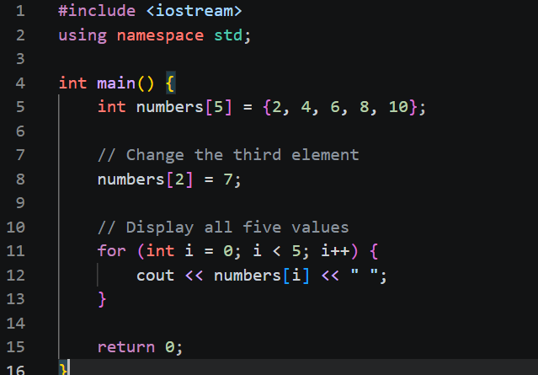
Output:
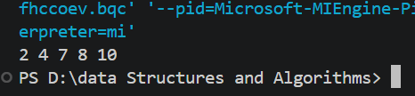
Outcomes: the third element has an index at 2 since arrays start at 0 so the number 6 is replaced with 7 and then the loop runs at o(n) since it is looping through n elements only once.

Task 2:
Code:
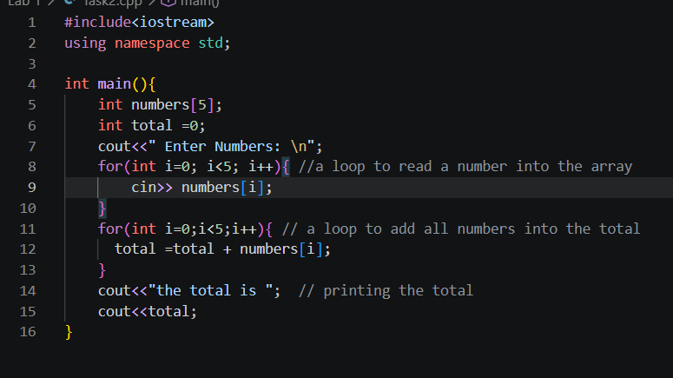
Outputs:

Test input | Expected total | Actual total
1 2 3 4 5 | 15 | 15
0 0 0 0 0 | 0 | 0
-2 4 -1 0 3 | 4 | 4
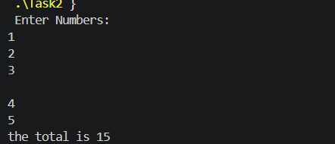
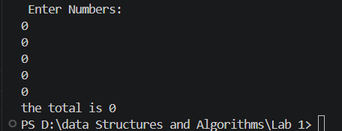
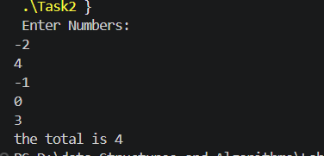
Outcomes: After doing all three iterations we see that one loop assigns values to each index value and one loop then adds that value at each index to a pre-established total of 0.

Task 3:

Code:
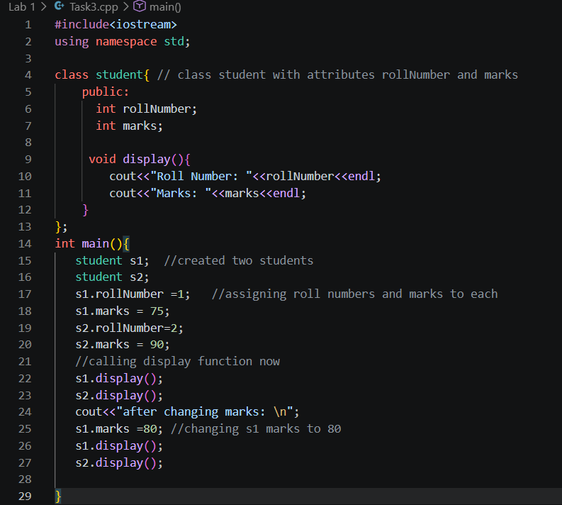
Output:
Before Running | After Running
Roll Number: 1  Marks: 75  Roll Number: 2  Marks: 90  After changing marks  Roll Number: 1  Marks: 80  Roll Number: 2  Marks: 90 | 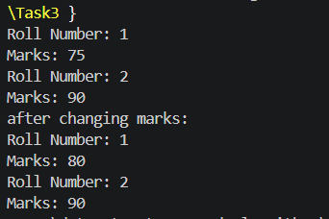
Outcomes: We learned that if we modify a public attribute even after calling a function where that attribute is used the attribute will change and the previous value will be overwritten.

Task 4:

Code:
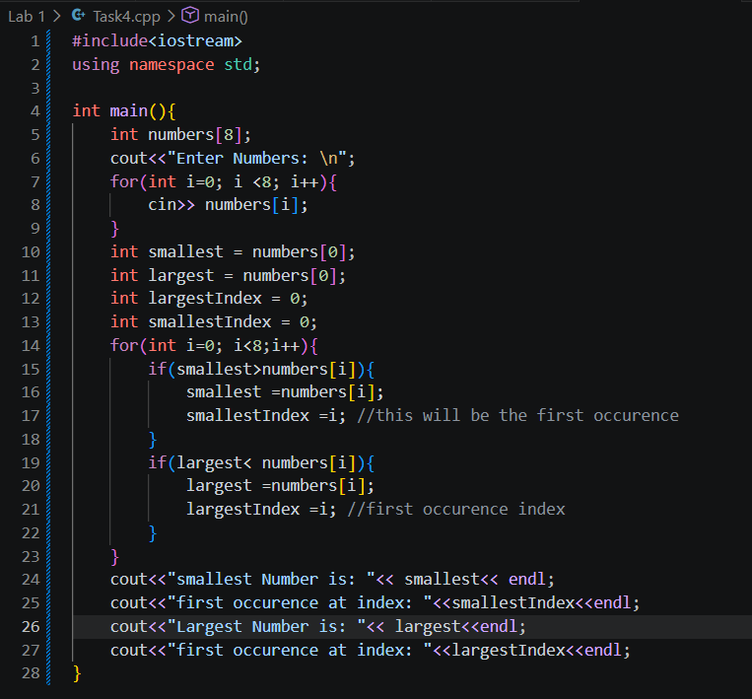
Output:
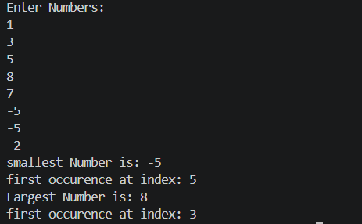

Outcomes: we report the first occurrence index of the value that is repeating to ensure that the value that we saw first was considered the smaller or larger value. We use the first loop to assign values and then the next loop to find the smallest and largest values simultaneously.

Task 5:

Code:
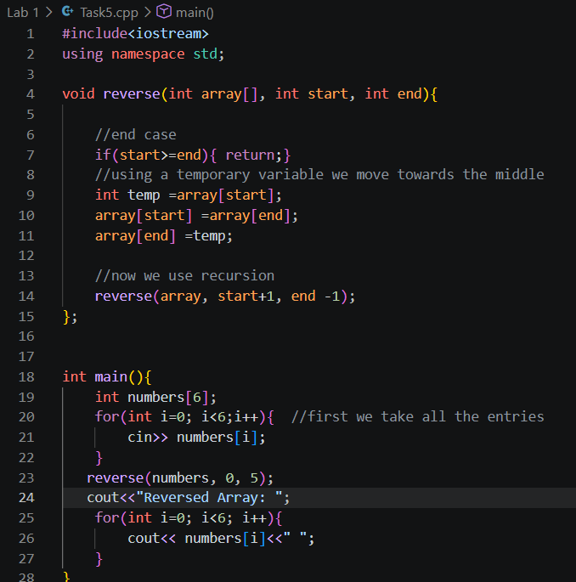
Output:
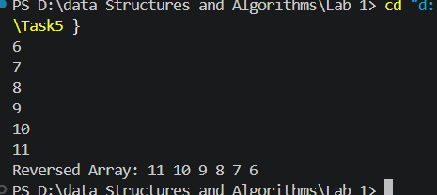
Outcomes: We first get an array then we send it to a function where we replace first and last elements and then recursively send the array back again into the function but by ifrst increasing the start index and decreasing the last index until the start is greater or equal to the end we complete the function and the array is returned fully modified already.

Task 6:

Code:
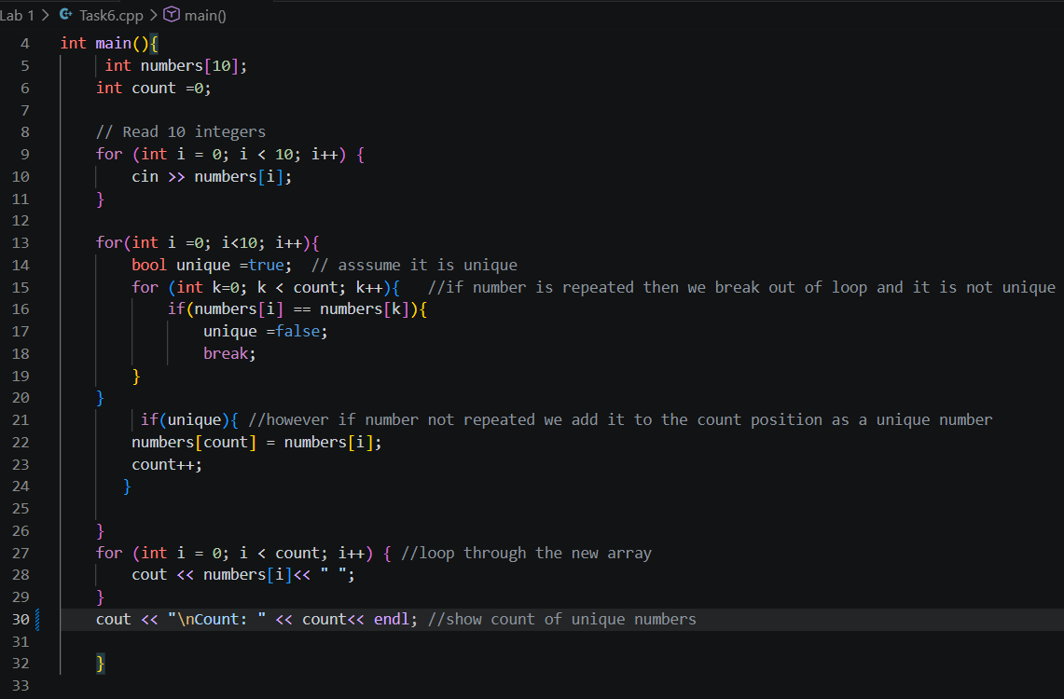
Output:
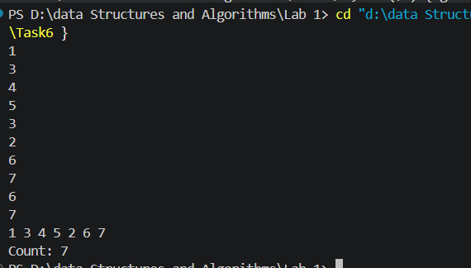

Outcomes:
We use a different count variable and a boolean logic to see if a number is repeated or not and then we print the only unique numbers in the same array and print the count as well.

Github Link: https://github.com/nffaisal/Data-Structures-and-Algorithms

